Kingsway Christian College
Maths Department

Course: Math Methods unit 3
Assessment Task: Test 3
Student Name: ________________________________________________________
Date: 11th & 12th May 2017
Assessment Score: ____________ / 71
Year Score: __________________
Comments: ________________________________________________________
___________________________________________________________________________
___________________________________________________________________________
___________________________________________________________________________
___________________________________________________________________________
___________________________________________________________________________
___________________________________________________________________________
___________________________________________________________________________
___________________________________________________________________________

Teacher signature: ________________________________________________________

Parent/ Guardian signature: _____________________________________________
Comments: ________________________________________________________
___________________________________________________________________________
___________________________________________________________________________
___________________________________________________________________________
___________________________________________________________________________

Math Methods Unit 3 Test 3 2017
Anti - Differentiation
Resource Free Time: 50 minutes Marks: / 46
Only a formula sheet is allowed for this section. No calculator or notes allowed.

Question 1 (12 marks)
Evaluate each of the following, showing all working. Leave all answers with positive indices.
- (1 mark)

- $\int{3x{\left(x^{2}-2\right)}^{3}dx}$ (3 marks)

- (3 marks)

- (2 marks)

If it is given that $f\left(x\right)$ is continuous everywhere and that $\int_{4}^{10}{f\left(x\right)dx= -10, }$ find:
- $\int_{1}^{3}{f\left(3x+1\right)dx }$ (3 marks)

Question 2 (15 marks)
Evaluate the following, showing full working.
- (3 marks)

- $-3\int_{π}^{2π}{\cos\left(3x\right)dx}$ (3 marks)

- (3 marks)

- $\frac{d}{dx}$ $\int_{4}^{x²}{\frac{2}{3t^{3}-1} dt}$ (3 marks)

- $\int_{1}^{2}{\frac{d}{dx}\left(\frac{x³}{x^{2}+1} \right) dx}$ (3 marks)

Question 3 (3 marks)
The derivative of is given by . Given that , find an expression for .

Question 4 (3 marks)
The area labelled B is two times the area labelled A. Express b in terms of a.
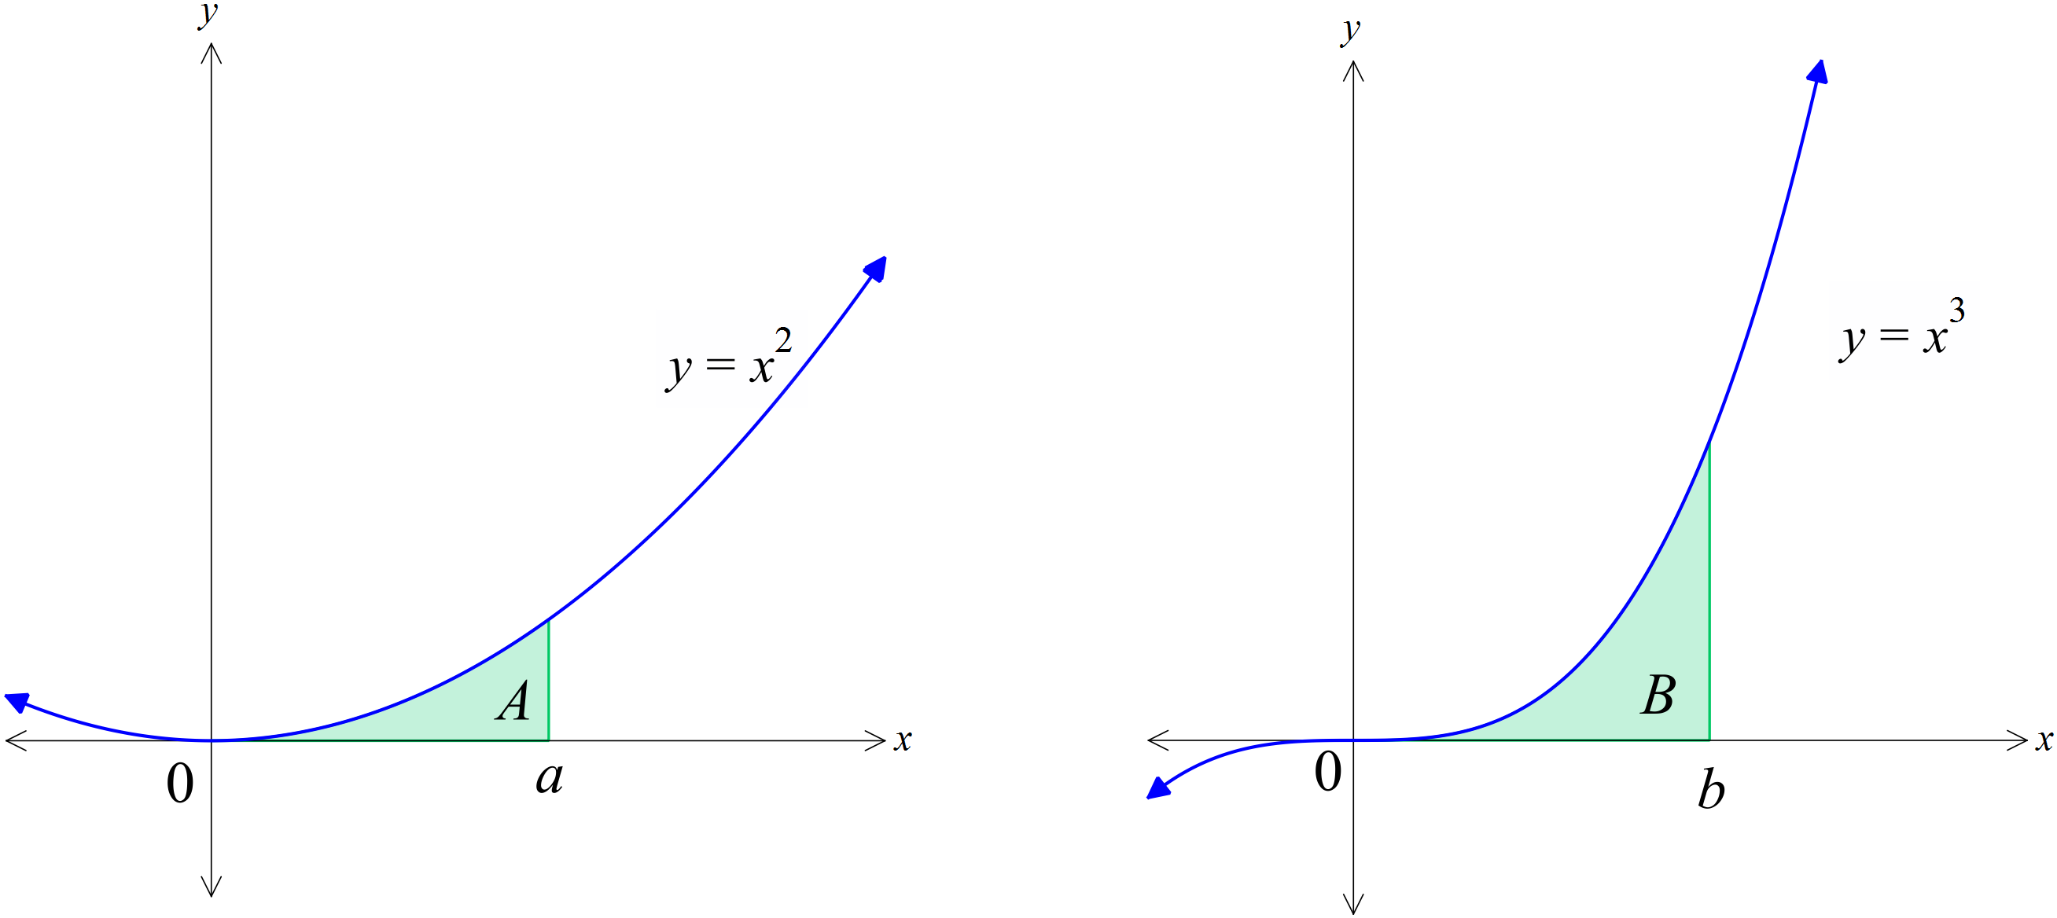

Question 5 (3 marks)
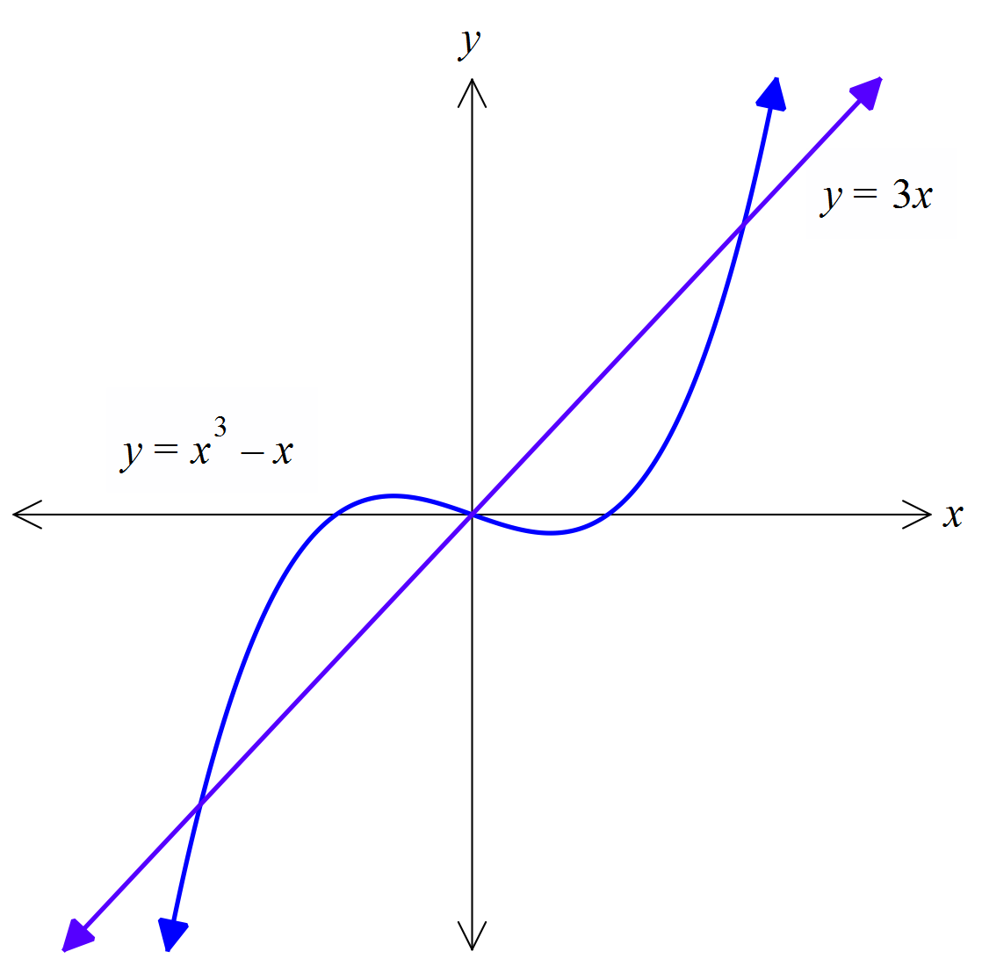Find the exact area bound by the two curves shown below.

Question 6 (4 marks)
Determine the function y given that 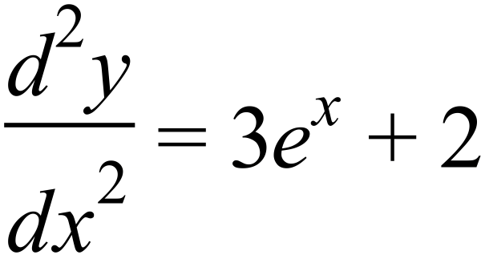 and 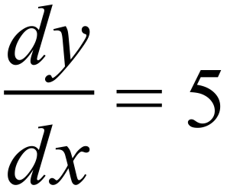 when x = 0 and 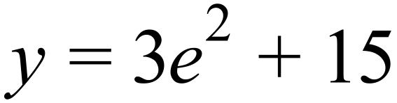 when x = 2.

Question 7 (6 marks)
The gradient function of is given by . Determine the values of a and b if and .

END OF PAPER 1
EXTRA PAGE FOR WORK OUT

